Segurança de Sistemas Informáticos

TP1: Coleta Passiva de Informações

# Recolha de informação de domínios

Para esta questão decidimos recolher informação relativa aos domínios reddit.com e (preencher).

|  |  |  |
| --- | --- | --- |
| **Item** | **Dados** | **Descrição** |
| Nome da empresa | Reddit | Fundado em 2005 em Massachusetts |
| Domínio | Reddit.com |  |
| Endereço da empresa | about.reddit.com |  |
| CEO ou Gestor principal | Steve Huffman | Tornou-se CEO em 2015 |
| Responsável pelo domínio | Domain Administrator | Nome dado pelo comando WHOIS |
| Responsável pelos endereços IP’s | Fastly | Localizada em San Francisco, opera desde 2011 |
| Responsável pela página Web ou setor de tecnologia |  |  |
| Endereço IP do Servidor Principal | 151.101.1.140  151.101.129.140  151.101.193.140  151.101.65.140 |  |
| Localização de Servidor Web | San Francisco, California, EUA |  |
| Tipo de tecnologias utilizadas pela empresa (página Web, funcionário) | Python, Amazon Web Services e Lucidworks Fusion | Código fonte disponível em: https://github.com/reddit/ |

# Pessoas de interesse

|  |  |  |
| --- | --- | --- |
| **Item** | **Dados** | **Descrição** |
| Nome | Steven Huffman |  |
| Endereço | São Francisco, EUA |  |
| Estado Civil | Casado |  |
| Telemóvel |  |  |
| Currículo | Computer Science na University of Virginia |  |
| Resumo da Pessoa |  |  |

# Fontes

* Reddit

<https://redditblog.com/2017/09/07/the-search-for-better-search-at-reddit/>

<https://en.wikipedia.org/wiki/Reddit>

<https://www.reddit.com/r/reddit.com/comments/9od7i/dear_reddit_steve_spez_huffman_is_getting_married/>

<https://www.linkedin.com/in/shuffman56>

# Anexos

## Informação Raw de WHOIS do endereço reddit.com

Domain Name: reddit.com

Registry Domain ID: 153584275_DOMAIN_COM-VRSN

Registrar WHOIS Server: whois.markmonitor.com

Registrar URL: http://www.markmonitor.com

Updated Date: 2017-07-12T14:02:38-0700

Creation Date: 2005-04-29T10:59:19-0700

Registrar Registration Expiration Date: 2020-04-29T10:59:19-0700

Registrar: MarkMonitor, Inc.

Registrar IANA ID: 292

Registrar Abuse Contact Email: abusecomplaints@markmonitor.com

Registrar Abuse Contact Phone: +1.2083895740

Domain Status: clientUpdateProhibited (https://www.icann.org/epp#clientUpdateProhibited)

Domain Status: clientTransferProhibited (https://www.icann.org/epp#clientTransferProhibited)

Domain Status: clientDeleteProhibited (https://www.icann.org/epp#clientDeleteProhibited)

Domain Status: serverUpdateProhibited (https://www.icann.org/epp#serverUpdateProhibited)

Domain Status: serverTransferProhibited (https://www.icann.org/epp#serverTransferProhibited)

Domain Status: serverDeleteProhibited (https://www.icann.org/epp#serverDeleteProhibited)

Registry Registrant ID:

Registrant Name: Domain Administrator

Registrant Organization: Reddit Inc.

Registrant Street: 548 Market St.,

Registrant City: San Francisco

Registrant State/Province: CA

Registrant Postal Code: 94104

Registrant Country: US

Registrant Phone: +1.4156662330

Registrant Phone Ext:

Registrant Fax: +1.9999999999

Registrant Fax Ext:

Registrant Email: domainadmin@reddit.com

Registry Admin ID:

Admin Name: Domain Administrator

Admin Organization: Reddit Inc.

Admin Street: 548 Market St.,

Admin City: San Francisco

Admin State/Province: CA

Admin Postal Code: 94104

Admin Country: US

Admin Phone: +1.4156662330

Admin Phone Ext:

Admin Fax: +1.9999999999

Admin Fax Ext:

Admin Email: domainadmin@reddit.com

Registry Tech ID:

Tech Name: Domain Administrator

Tech Organization: Reddit Inc.

Tech Street: 548 Market St.,

Tech City: San Francisco

Tech State/Province: CA

Tech Postal Code: 94104

Tech Country: US

Tech Phone: +1.4156662330

Tech Phone Ext:

Tech Fax: +1.9999999999

Tech Fax Ext:

Tech Email: domainadmin@reddit.com

Name Server: ns-378.awsdns-47.com

Name Server: ns-1029.awsdns-00.org

Name Server: ns-1887.awsdns-43.co.uk

Name Server: ns-557.awsdns-05.net

DNSSEC: unsigned

## Informação dos endereços IP de reddit.com

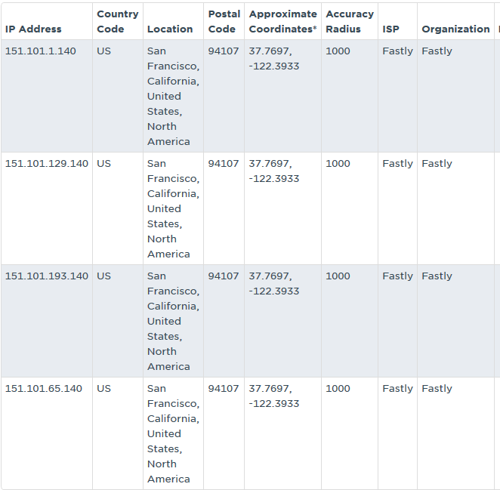

# Recolha de informação de domínios

Para esta questão decidimos recolher informação relativa aos domínios reddit.com e (preencher).

|  |  |  |
| --- | --- | --- |
| **Item** | **Dados** | **Descrição** |
| Nome da empresa | Amazon | Fundada a 5 de julho de 1994, em Seattle, Washington |
| Domínio | amazon.com |  |
| Endereço da empresa | P.O. Box 8102 Reno, NV, USA |  |
| CEO ou Gestor principal | Jeff Bezos | Fundador da empresa, CEO desde 1994. |
| Responsável pelo domínio | Hostmaster, Amazon Legal Dept | Nome dado pelo comando WHOIS. |
| Responsável pelos endereços IP’s | Amazon | Localizada em Ashburn, Virginia. |
| Responsável pela página Web ou setor de tecnologia | Hostmaster, Amazon Legal Dept | Nome dado pelo comando WHOIS. |
| Endereço IP do Servidor Principal | 54.239.17.7  54.239.25.208  54.239.17.6  54.239.25.192  54.239.26.128  54.239.25.200 | Serviço de Email:  amazon-smtp.amazon.com. |
| Localização de Servidor Web | Ashburn, Virginia, USA |  |
| Tipo de tecnologias utilizadas pela empresa (página Web, funcionário) | JAVA, C++, Perl, JavaScript, Oracle Database. | Client-Side, Server-Side, Database |

# Pessoas de interesse

|  |  |  |
| --- | --- | --- |
| **Item** | **Dados** | **Descrição** |
| Nome | Jeff Bezos | Nascido a 12 de janeiro de 1964, Albuquerque, New Mexico, USA. |
| Endereço | 2320-2330 S. Street, Washington | Alegado endereço. |
| Estado Civil | Casado | Casado com MacKenzie Bezos desde 1993 (4 filhos). |
| Telemóvel | N/A | N/A |
| Currículo | Formado em Computer Science e Electrical Engineering. | Universidade de Princeton. Graus de honra *Phi Betta Kappa* e *Tau Beta Pi*. |
| Resumo da Pessoa | Participação especial no filme de ficção científica *Star Trek Beyond* (2016). Net worth de US$82.6 billion. | Interpretou um *Starfleet Official.* Tornou-se o homem mais rico do mundo a 27 de julho de 2017. Acabaria por perder esse estatuto ainda nesse mesmo dia. |

# Fontes

* Amazon

<https://www.geekwire.com/2017/jeff-bezos-reported-buyer-largest-house-washington-d-c-23m-cash/>

<https://en.wikipedia.org/wiki/MacKenzie_Bezos>

<https://en.wikipedia.org/wiki/Tau_Beta_Pi>

<http://www.bbc.com/news/entertainment-arts-36857001>

<https://en.wikipedia.org/wiki/Phi_Beta_Kappa_Society>

<https://en.wikipedia.org/wiki/Amazon_(company)>

<https://en.wikipedia.org/wiki/Programming_languages_used_in_most_popular_websites>

# Anexos

## Informação Raw de WHOIS do endereço amazon.com

Domain Name: amazon.com

Registry Domain ID: 281209_DOMAIN_COM-VRSN

Registrar WHOIS Server: whois.markmonitor.com

Registrar URL: http://www.markmonitor.com

Updated Date: 2014-04-30T12:11:08-0700

Creation Date: 1994-10-31T21:00:00-0800

Registrar Registration Expiration Date: 2022-10-30T21:00:00-0700

Registrar: MarkMonitor, Inc.

Registrar IANA ID: 292

Registrar Abuse Contact Email: abusecomplaints@markmonitor.com

Registrar Abuse Contact Phone: +1.2083895740

Domain Status: clientUpdateProhibited (https://www.icann.org/epp#clientUpdateProhibited)

Domain Status: clientTransferProhibited (https://www.icann.org/epp#clientTransferProhibited)

Domain Status: clientDeleteProhibited (https://www.icann.org/epp#clientDeleteProhibited)

Domain Status: serverUpdateProhibited (https://www.icann.org/epp#serverUpdateProhibited)

Domain Status: serverTransferProhibited (https://www.icann.org/epp#serverTransferProhibited)

Domain Status: serverDeleteProhibited (https://www.icann.org/epp#serverDeleteProhibited)

Registry Registrant ID:

Registrant Name: Hostmaster, Amazon Legal Dept.

Registrant Organization: Amazon Technologies, Inc.

Registrant Street: P.O. Box 8102

Registrant City: Reno

Registrant State/Province: NV

Registrant Postal Code: 89507

Registrant Country: US

Registrant Phone: +1.2062664064

Registrant Phone Ext:

Registrant Fax: +1.2062667010

Registrant Fax Ext:

Registrant Email: hostmaster@amazon.com

Registry Admin ID:

Admin Name: Hostmaster, Amazon Legal Dept.

Admin Organization: Amazon Technologies, Inc.

Admin Street: P.O. Box 8102

Admin City: Reno

Admin State/Province: NV

Admin Postal Code: 89507

Admin Country: US

Admin Phone: +1.2062664064

Admin Phone Ext:

Admin Fax: +1.2062667010

Admin Fax Ext:

Admin Email: hostmaster@amazon.com

Registry Tech ID:

Tech Name: Hostmaster, Amazon Legal Dept.

Tech Organization: Amazon Technologies, Inc.

Tech Street: P.O. Box 8102

Tech City: Reno

Tech State/Province: NV

Tech Postal Code: 89507

Tech Country: US

Tech Phone: +1.2062664064

Tech Phone Ext:

Tech Fax: +1.2062667010

Tech Fax Ext:

Tech Email: hostmaster@amazon.com

Name Server: ns1.p31.dynect.net

Name Server: ns4.p31.dynect.net

Name Server: ns2.p31.dynect.net

Name Server: pdns1.ultradns.net

Name Server: ns3.p31.dynect.net

Name Server: pdns6.ultradns.co.uk

DNSSEC: unsigned

## C:\Users\JoãoNuno\AppData\Local\Microsoft\Windows\INetCache\Content.Word\SSI - TP1 - Anexo 2.pngC:\Users\JoãoNuno\AppData\Local\Microsoft\Windows\INetCache\Content.Word\SSI - TP1 - Anexo 1.pngInformação dos endereços IP de amazon.com